AWS Web Application Firewall (WAF),AWS Systems Manager Parameter Store

AWS Web Application Firewall (WAF)
Introduction
AWS Web Application Firewall (AWS WAF) is a security service that protects your web applications from common web attacks such as:
- SQL Injection (SQLi)
- Cross-Site Scripting (XSS)
- Bot attacks
- DDoS Layer 7 attacks (when used with AWS Shield)
- IP-based attacks
- Rate-based attacks
AWS WAF filters and monitors incoming HTTP/HTTPS requests before they reach your application.
It works with:
- Amazon CloudFront
- Application Load Balancer (ALB)
- Amazon API Gateway
- AWS App Runner
- Amazon Cognito

Objective
After completing this lab, you will be able to:
- Understand AWS WAF
- Create a Web ACL
- Add security rules
- Block malicious traffic
- Allow legitimate users
- Protect an Application Load Balancer or API Gateway
- Test WAF rules

Simple Architecture
Users
|
|
Internet Requests
|
|
AWS Web Application Firewall
|
-------------------------
| | |
CloudFront ALB API Gateway
|
EC2 / Lambda
Features of AWS WAF
- Web ACL (Access Control List)
- Managed Rules
- Custom Rules
- Rate Limiting
- IP Blocking
- Geo Blocking
- Bot Protection
- Logging
- CloudWatch Metrics
AWS WAF Components
1. Web ACL
A Web ACL is the main firewall.
It contains:
- Rules
- Default action
- Associated resources

2. Rules
Rules inspect incoming requests.
Examples:
- Block IP
- Allow IP
- SQL Injection
- XSS
- Rate Limit
- Geo Restriction

3. Rule Groups
A collection of multiple rules.
AWS provides:
- AWS Managed Rules
- Custom Rule Groups

4. Managed Rules
AWS automatically updates these rules.
Examples:
- SQL Injection
- Linux attacks
- PHP attacks
- WordPress attacks
- Known Bad Inputs
- Anonymous IP

5. Custom Rules
Created by the user.
Examples:
- Block IP
- Allow Office IP
- Block Country
- Block URL
- Block User-Agent

Prerequisites
Before starting:
- AWS Account
- Basic knowledge of HTTP and HTTPS
- EC2 or ALB already created
- IAM permissions for:
  - AWS WAF
  - EC2
  - Elastic Load Balancer
  - CloudWatch
For this lab, you should already have:
- One Application Load Balancer
- One EC2 instance running Apache or Nginx
- Security Group allowing HTTP (80)

Step 1: Open AWS WAF
Search
WAF & Shield
Open
AWS WAF & Shield
Click
Create web ACL

Step 2: Configure Web ACL
Name
Demo-WebACL
Description
Protect ALB from common web attacks
Region
Select the same region as your ALB.
Example
US East (N. Virginia)
Click
Next
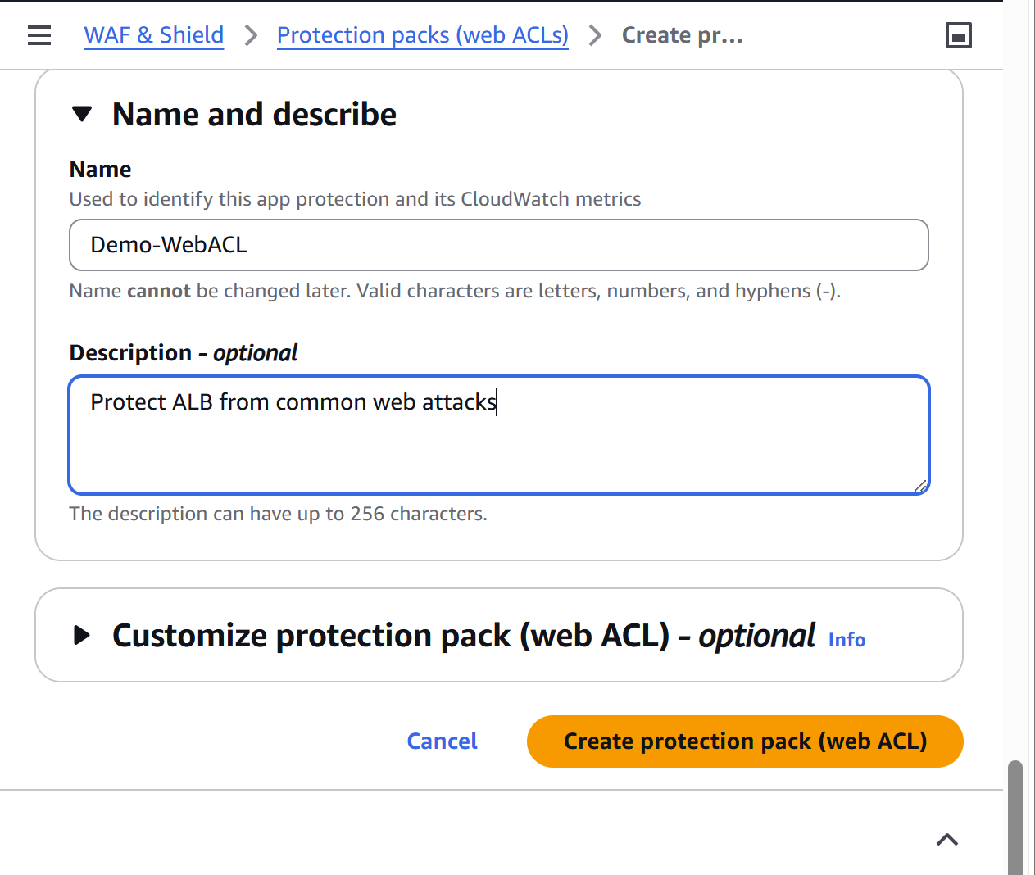

Step 3: Choose Resource Type
Under
Resource type
Choose
Regional resources
Because ALB is a regional resource.
Click
Add AWS resources
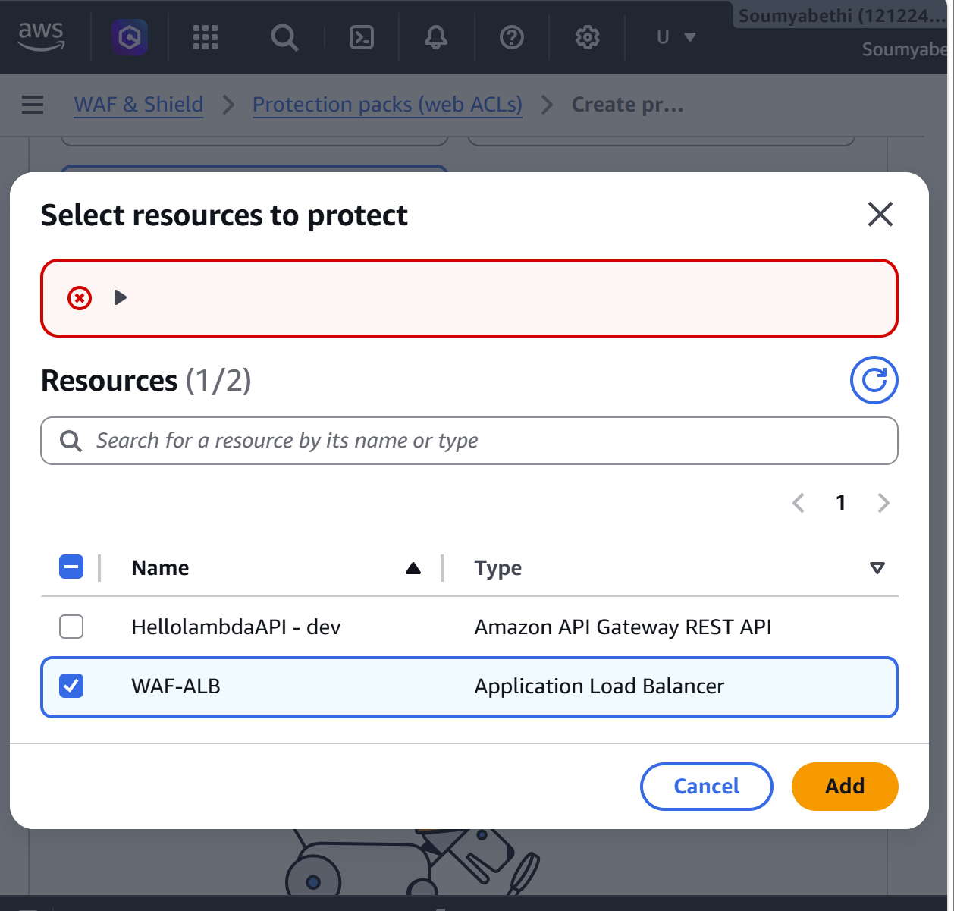

Step 4: Associate ALB
Select your Application Load Balancer.
Example
Apache-ALB
Click
Add
Click
Next

Step 5: Add Managed Rule Groups
Click
Add rules
Choose
Add managed rule groups

AWS Managed Rules
Expand
AWS Managed Rules
Select these rule groups:
1. Core Rule Set (Recommended)
Protects against
- SQL Injection
- XSS
- Remote File Inclusion
- Local File Inclusion
- Command Injection
Select
Core rule set

2. Known Bad Inputs
Blocks
- Invalid requests
- Bad user agents
- Malicious payloads
Select
Known bad inputs

3. Amazon IP Reputation List
Blocks requests from
- Botnets
- Malware
- Suspicious IPs
Select
Amazon IP reputation list

Click
Add rules
Click
Next
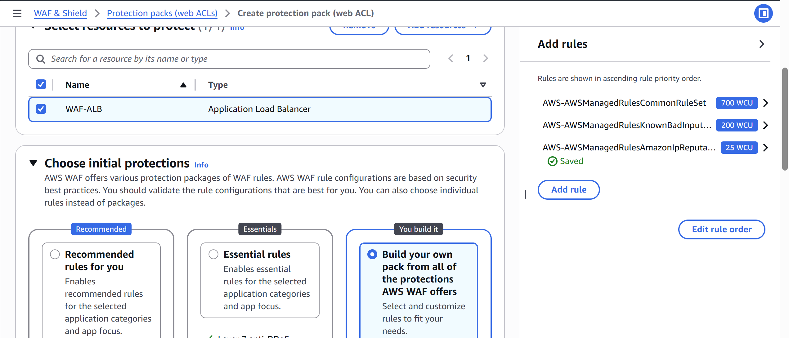

Step 6: Rule Priority
AWS automatically assigns priorities.
Example
1 Core Rule Set

2 Known Bad Inputs

3 IP Reputation
Leave default.
Click
Next
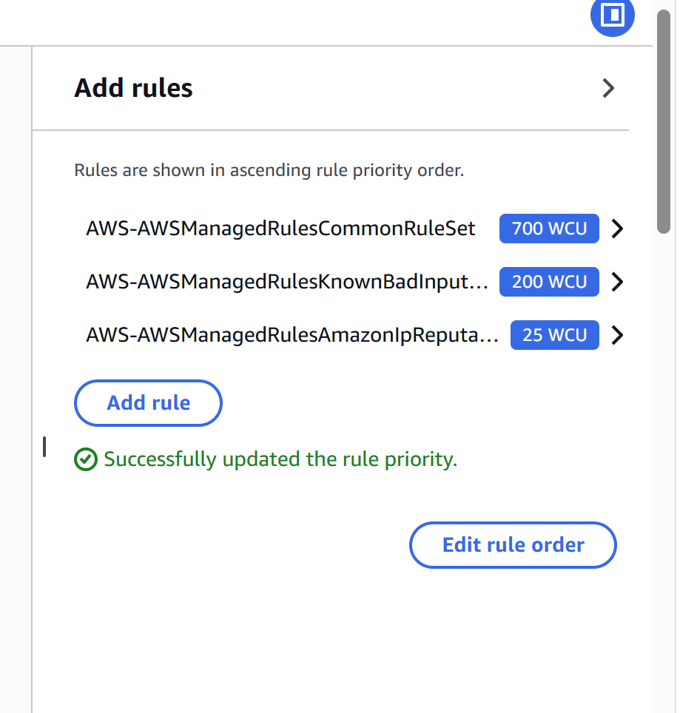

Step 7: Configure Metrics
Metric Name
DemoWAFMetrics
CloudWatch metrics will be created automatically.
Click
Next
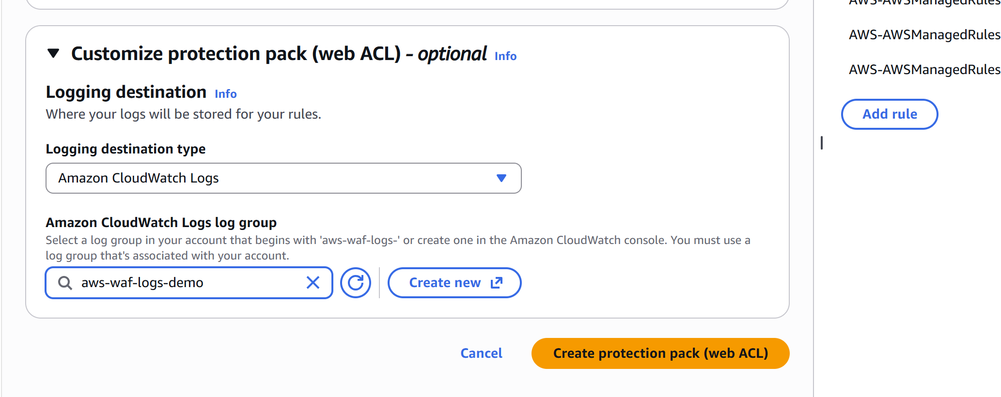

Step 8: Review
Review all settings.
Click
Create Web ACL
Creation takes about one minute.
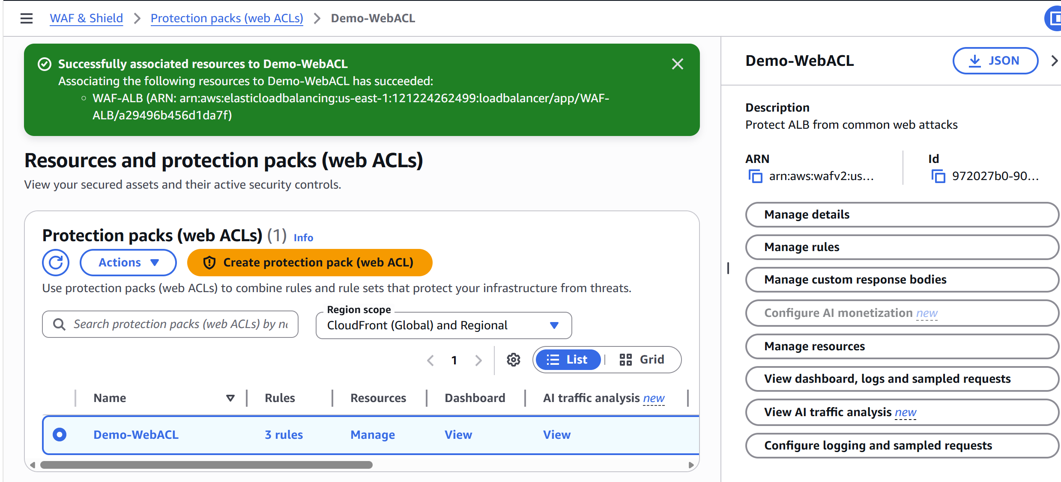

Step 9: Verify Association
Open
AWS WAF
Select
Demo-WebACL
Choose
Associated AWS resources
You should see
WAF-ALB
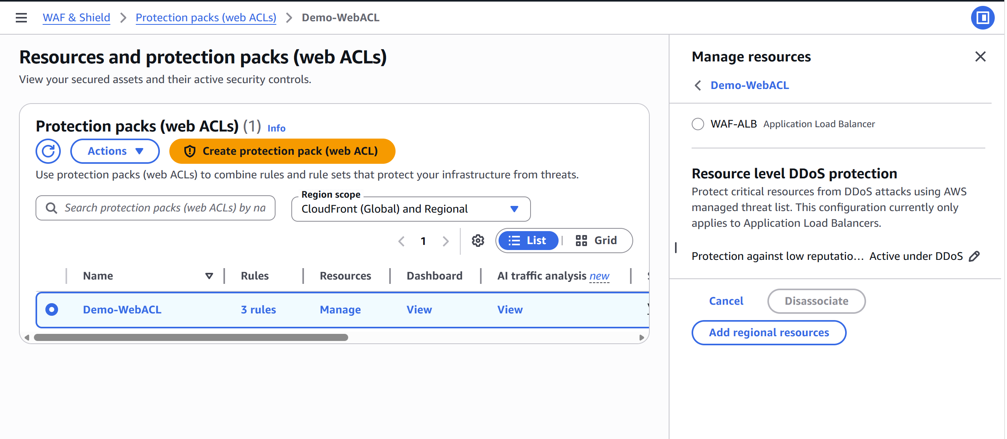

Step 10: Test Normal Traffic
Open your ALB DNS name.
Example
http://your-alb-dns-name
You should see your Apache page.
Example
Welcome to Apache Server
Normal requests should succeed.
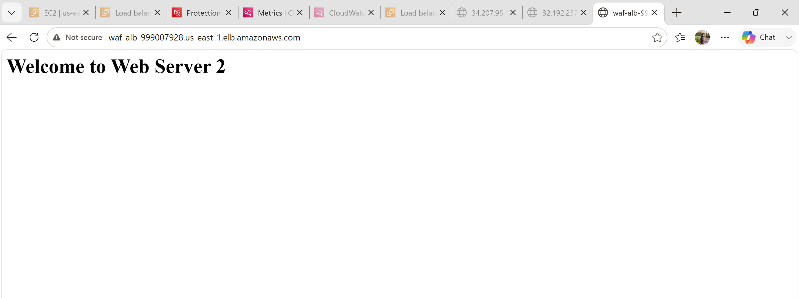

Step 11: Test SQL Injection Protection
In the browser, enter a URL like:
http://<WAF-ALB-999007928.us-east-1.elb.amazonaws.com /?id=' OR 1=1--
Or use:
http:// WAF-ALB-999007928.us-east-1.elb.amazonaws.com /login?user=admin'—
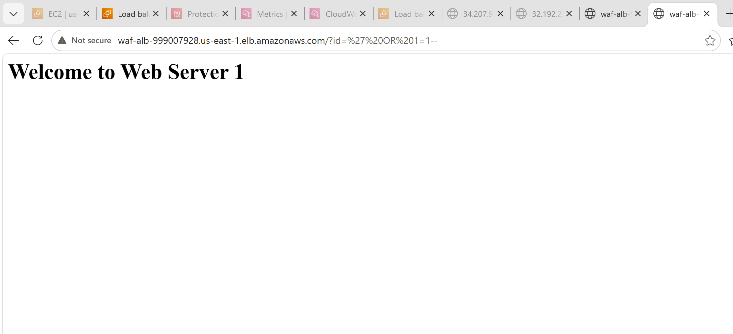
Added rule sql database
Save then test again
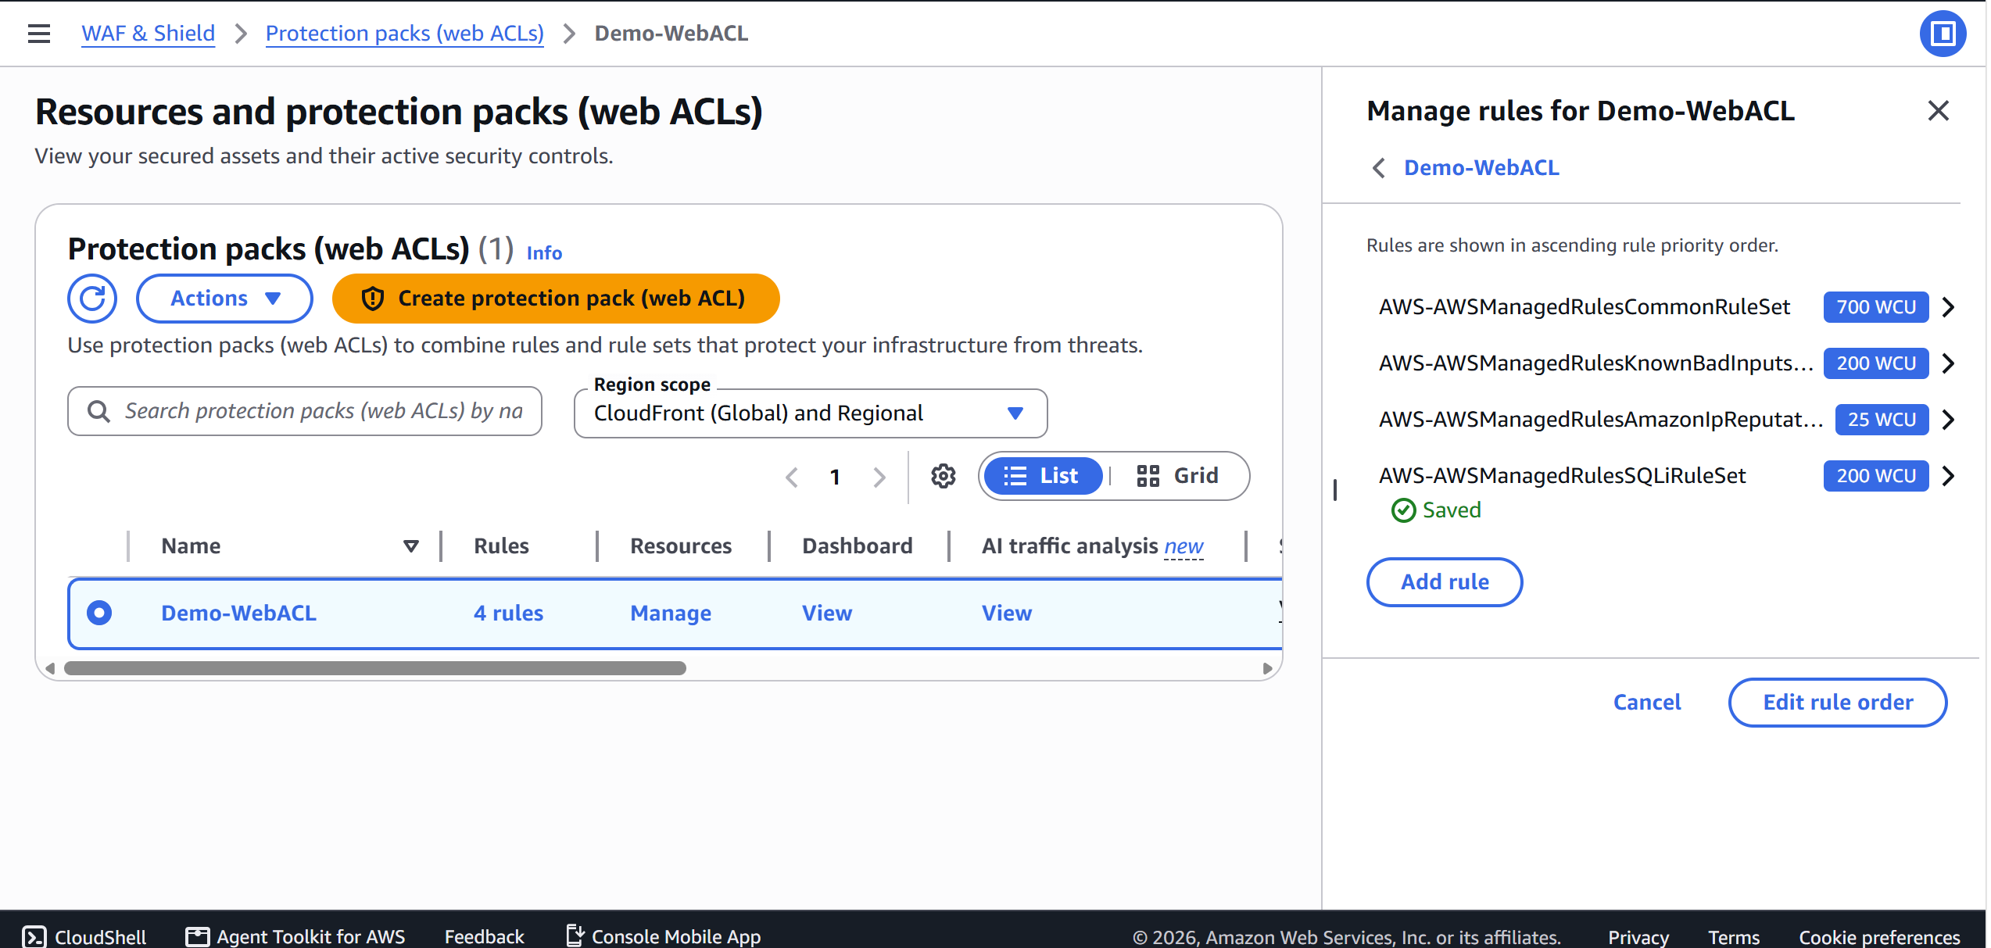
Expected result:
403 Forbidden
The request is blocked by the Core Rule Set.
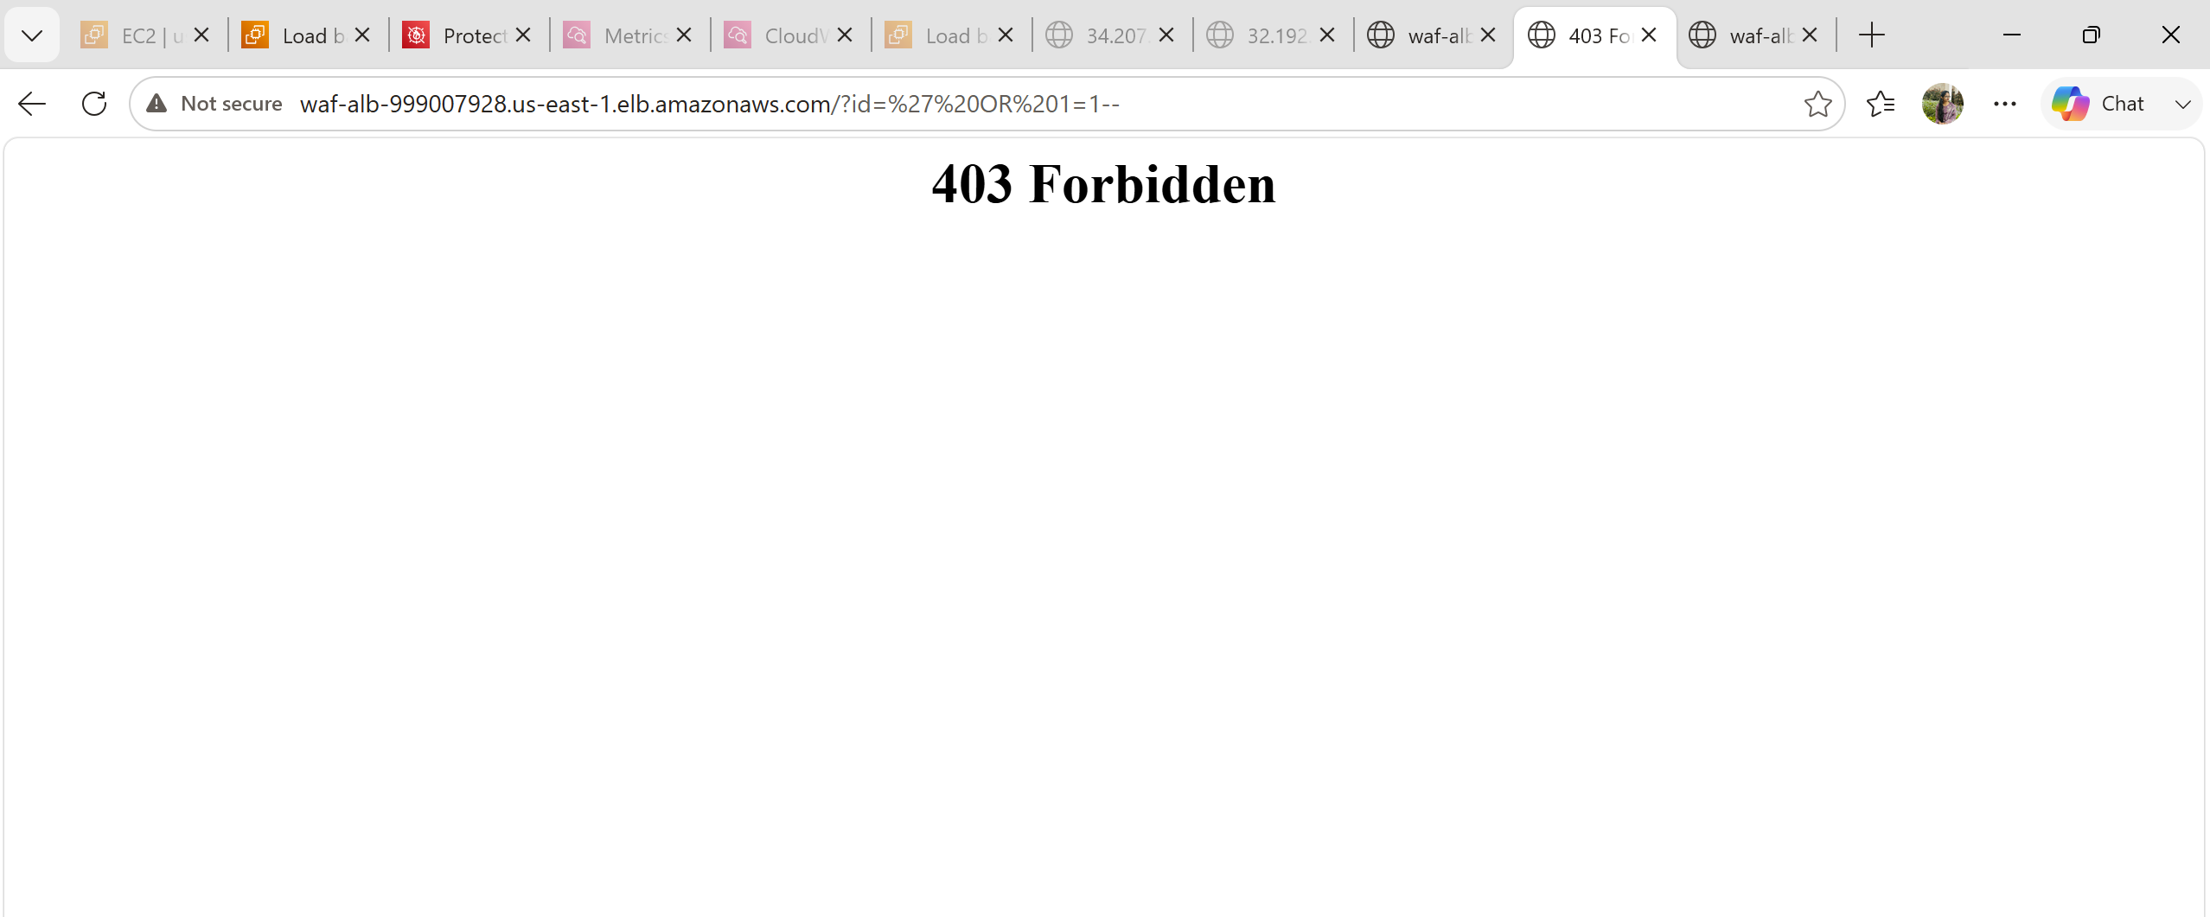

Step 12: Test Cross-Site Scripting (XSS)
Use a URL such as:
Expected result:
403 Forbidden
AWS WAF blocks the request.
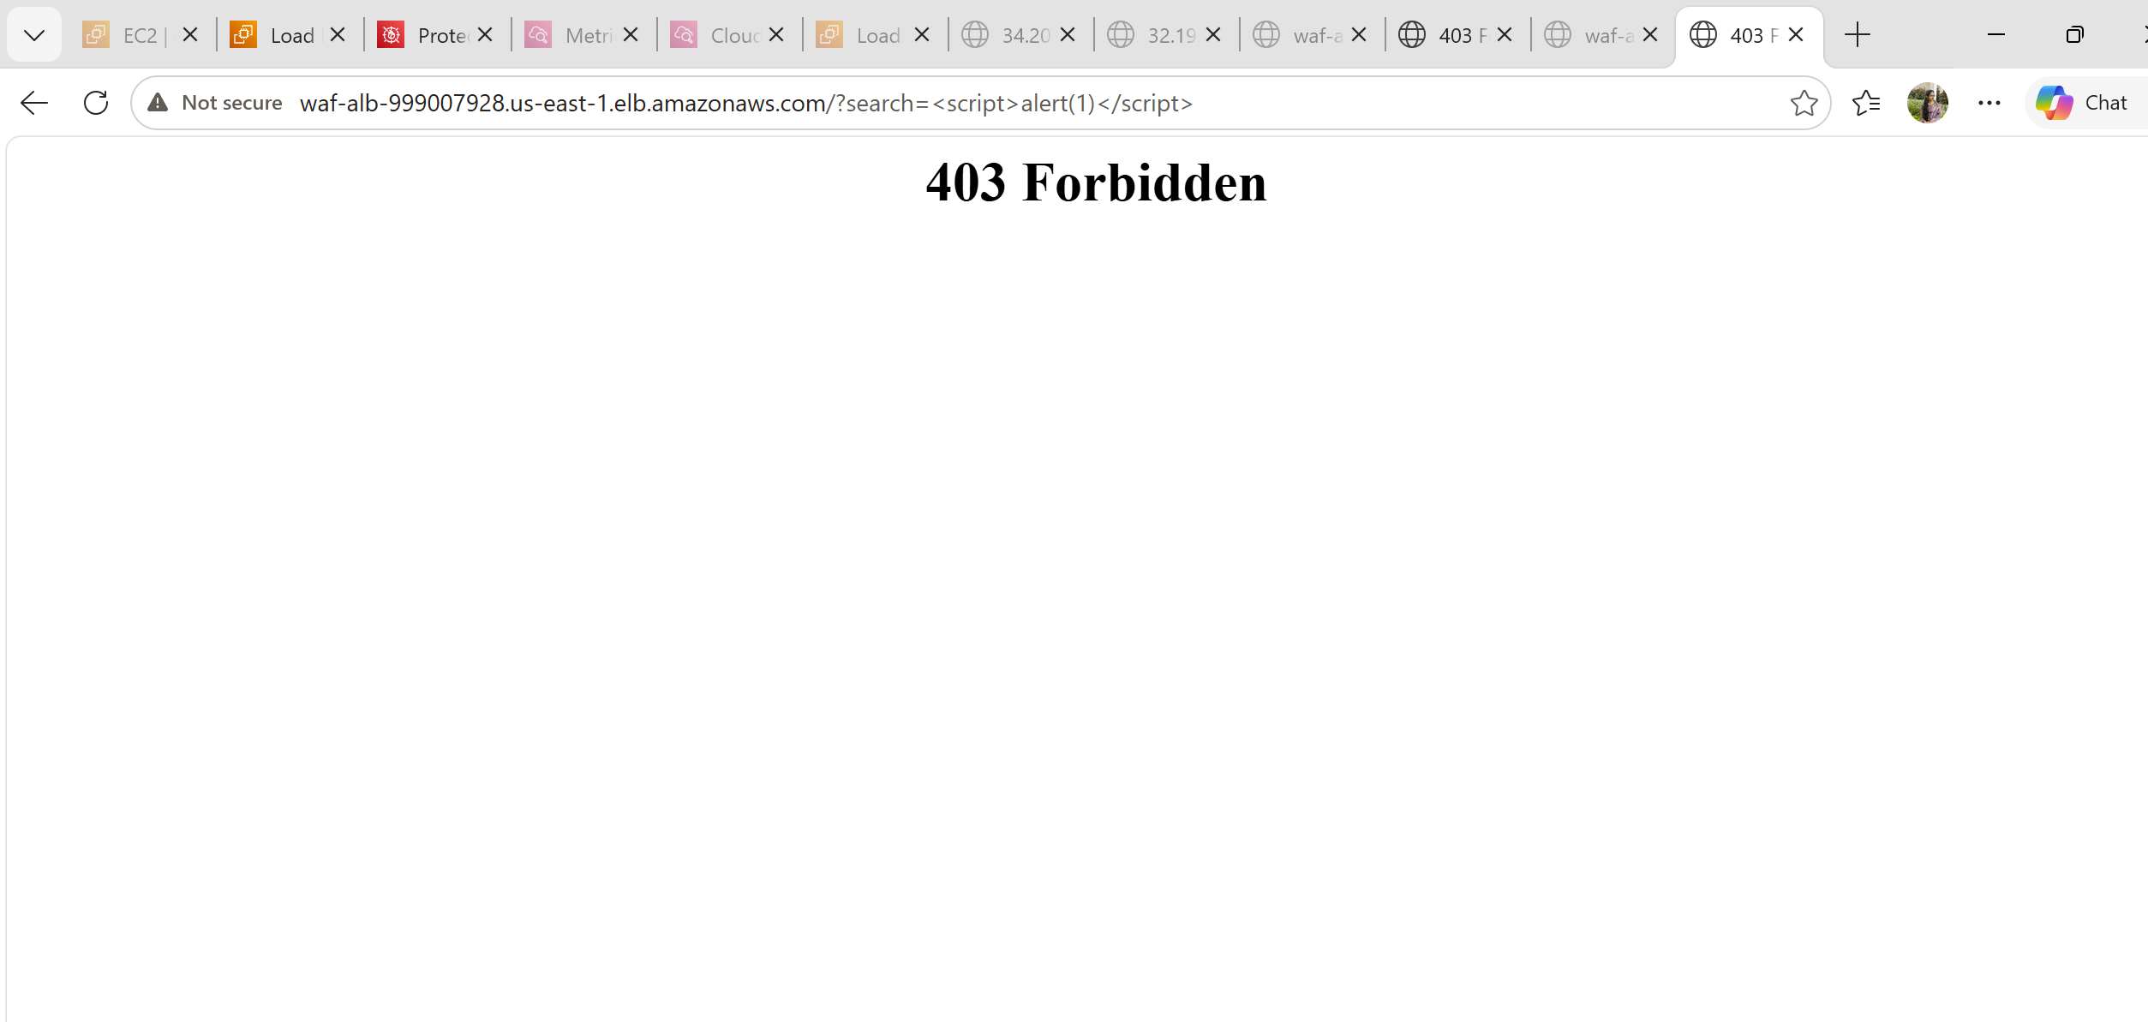

Step 13: Create a Custom Rule (Block a Specific IP)
Go to:
AWS WAF
→ Web ACL
→ Demo-WebACL
Click:
Rules
Click:
Add rules
Choose:
Add my own rules
Select:
Rule builder
Configure:
Rule name
Block-My-IP
Type
Regular rule
If a request
Matches the statement
Statement
IP address
Click:
Add IP set

Step 14: Create an IP Set
Click:
Create IP set
Enter:
Name
Blocked-IP
IP Version
IPv4
Addresses
Add your public IP in CIDR format:
124.123.141.143/32
(Replace with your own public IP.)
Create the IP set, return to the rule, and select it.
Set the action to:
Block
Save the rule and add it to the Web ACL.
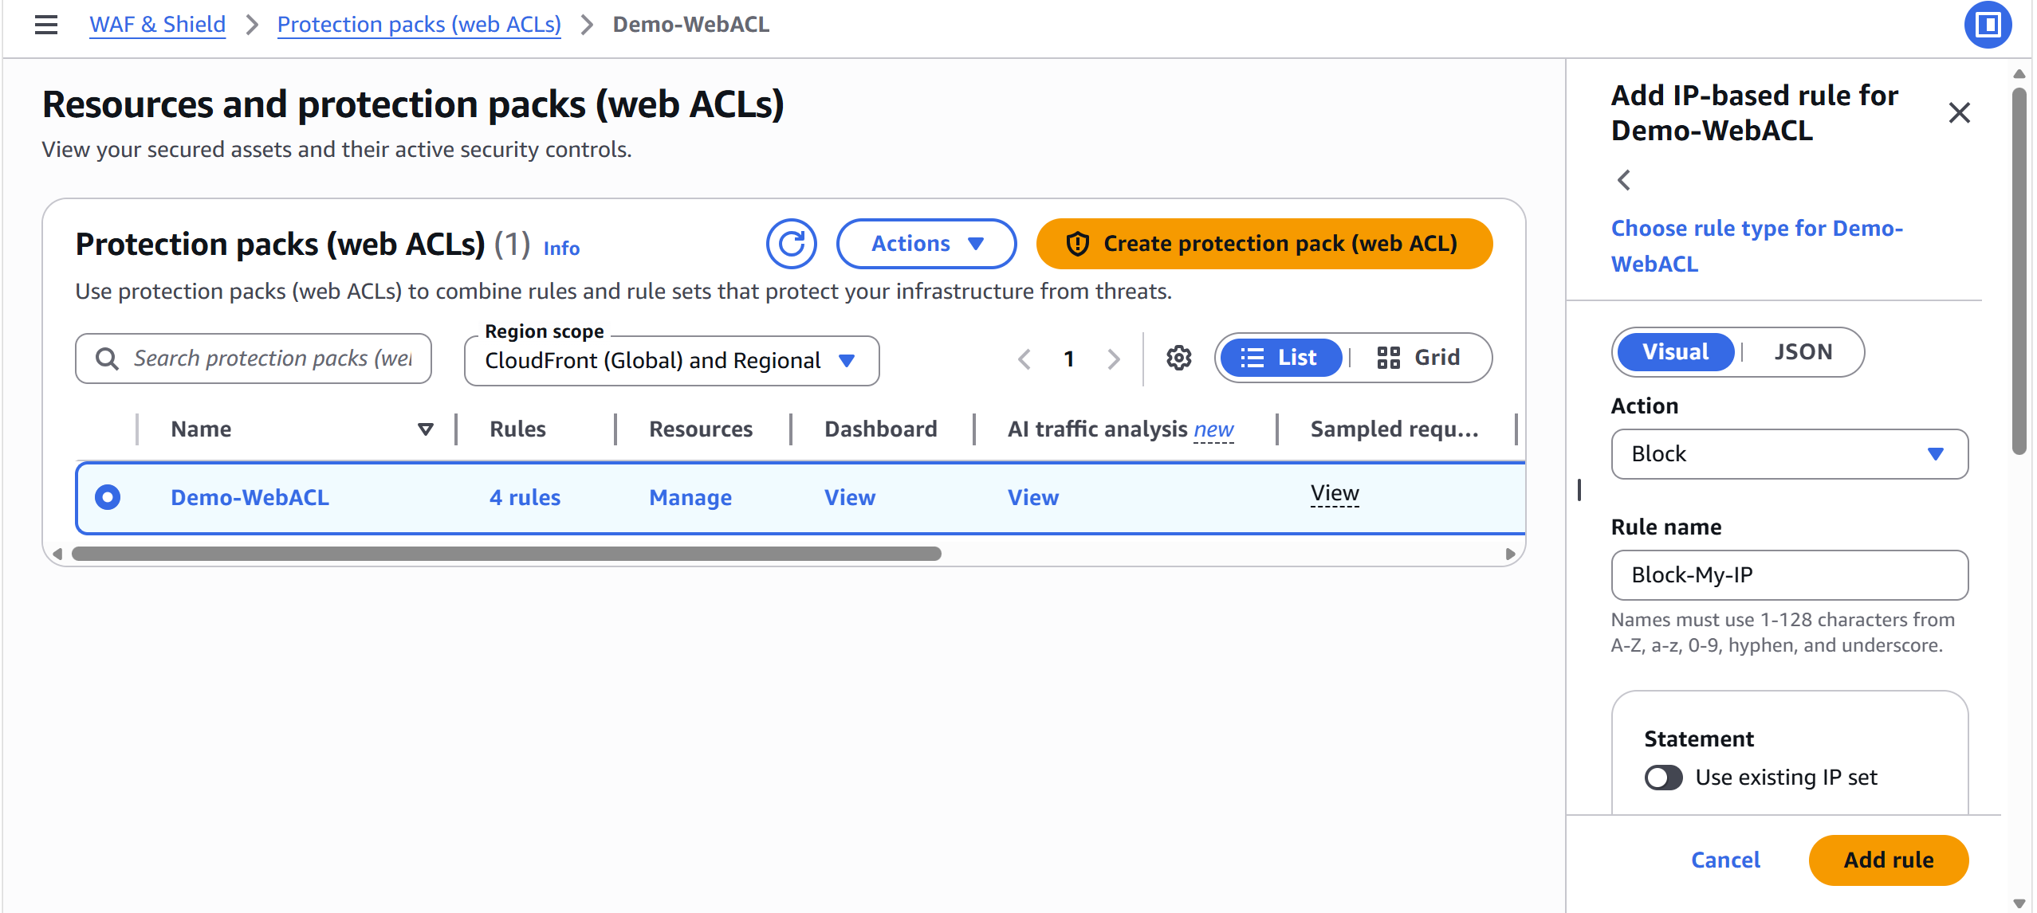

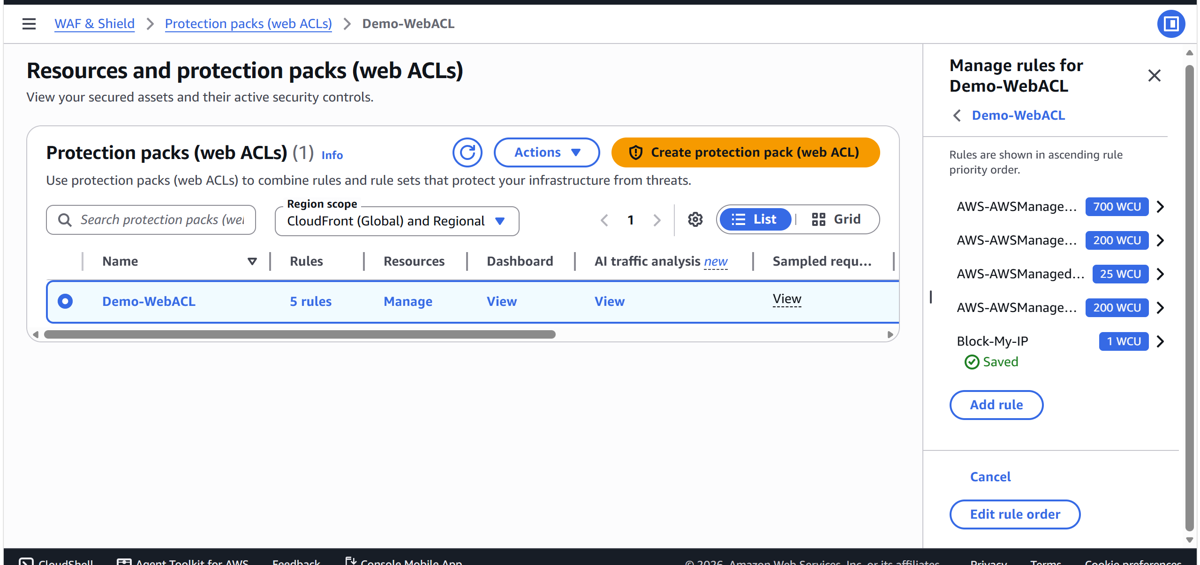
Step 15: Test the Custom Rule
From the blocked IP address, browse to your ALB.
Expected result:
403 Forbidden
Requests from other IPs should continue to work.
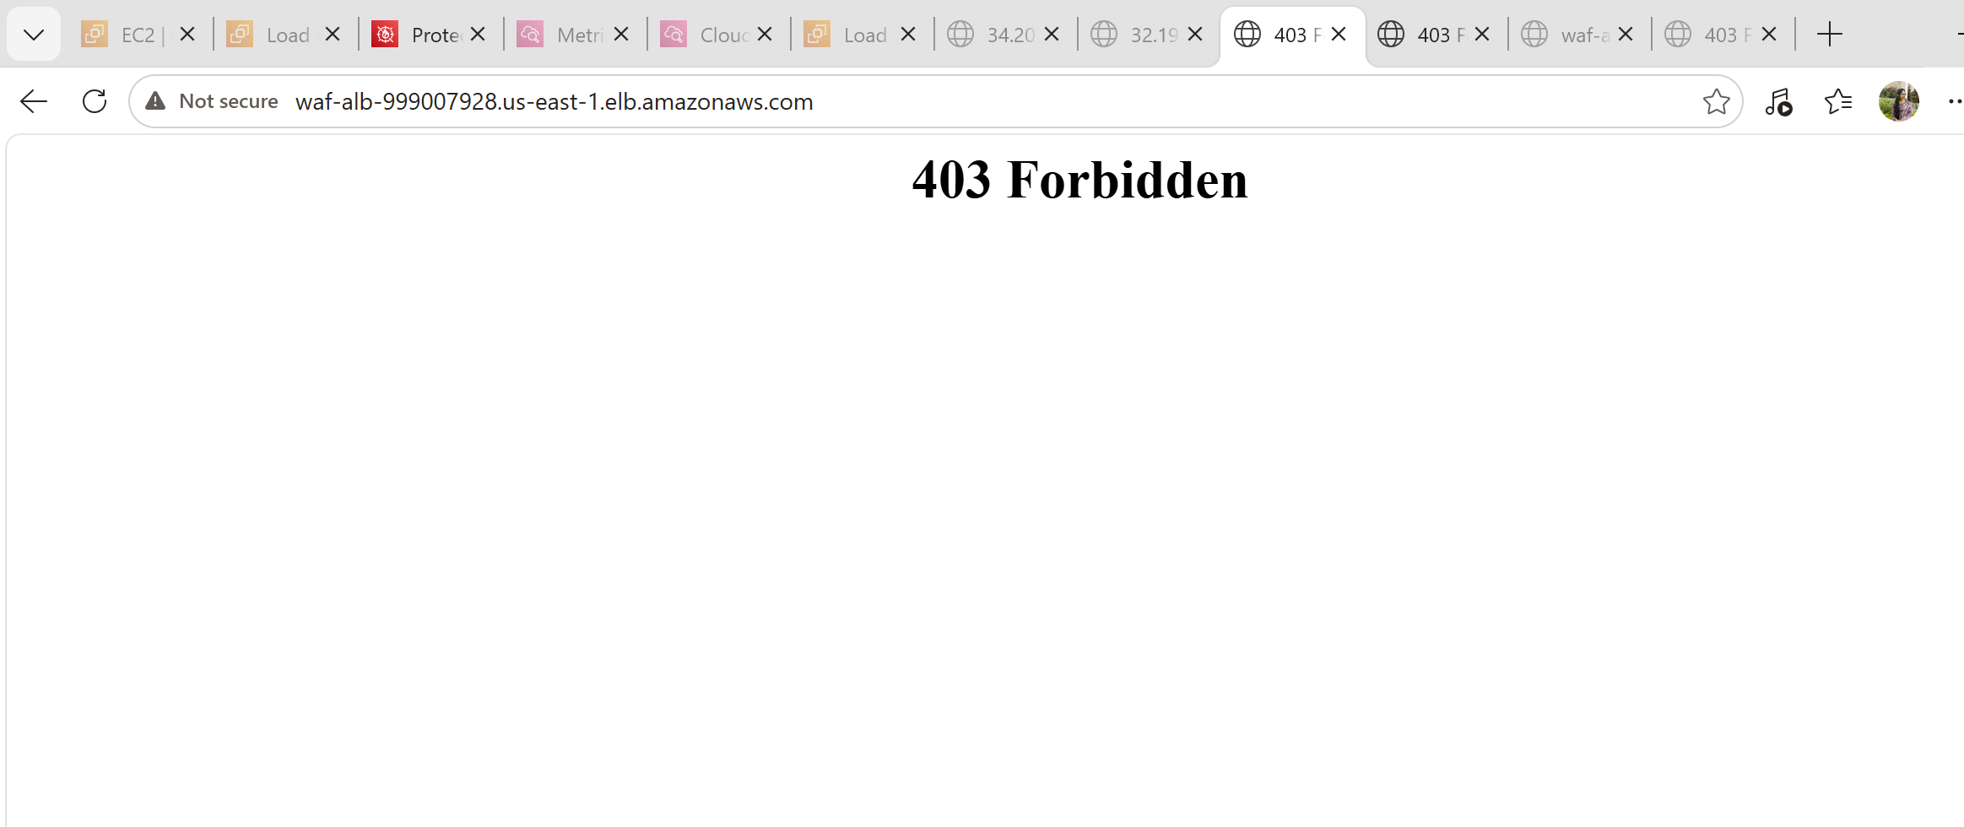

Step 16: View Sampled Requests
Go to:
AWS WAF
→ Web ACL
→ Demo-WebACL
Open:
Traffic overview
Click:
Sampled requests
You can see:
- Source IP
- Rule that matched
- Request path
- Action (Allow/Block)
- Timestamp
- 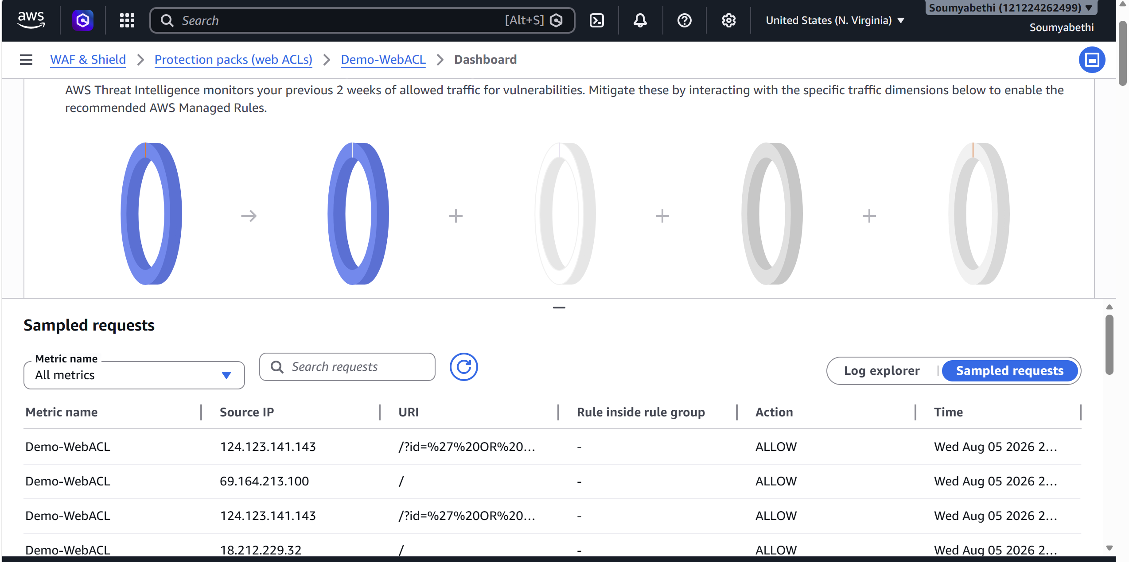

Step 17: Monitor with CloudWatch
Open:
CloudWatch
→ Metrics
→ WAFV2
View metrics such as:
- AllowedRequests
- BlockedRequests
- CountedRequests
You can also create CloudWatch alarms based on these metrics.
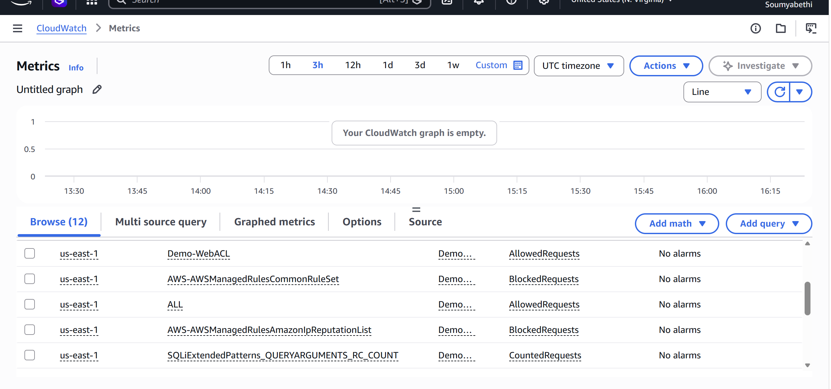

Step 18: Optional – Switch Rule Action to Count
If you want to observe traffic without blocking it:
Go to:
AWS WAF
→ Demo-WebACL
→ Rules
Edit a rule and change the action from:
Block
to:
Count
Save the changes. Requests will be logged as matches but not blocked.
Step 19:Cleaningup is important

AWS Systems Manager Parameter Store

Introduction
AWS Systems Manager Parameter Store is a secure, scalable, and centralized service that stores configuration data and secrets for your applications and AWS services.
Instead of hardcoding sensitive information like passwords, API keys, or database connection strings in your application or scripts, you can securely store them in Parameter Store and retrieve them whenever needed.
Parameter Store is a feature of AWS Systems Manager (SSM) and integrates with many AWS services such as Lambda, EC2, ECS, CloudFormation, CodeBuild, and CodePipeline.

Objective
After completing this hands-on lab, you will be able to:
- Understand what Parameter Store is.
- Create parameters.
- Store configuration values securely.
- Store encrypted secrets using AWS KMS.
- Retrieve parameters from the AWS Console.
- Retrieve parameters using AWS CLI.
- Access parameters from an EC2 instance.
- Understand parameter versions.
- Update parameters.
- Delete parameters.
- Understand real-world DevOps use cases.
Architecture:
Developer

│
│ Create Parameter
▼

AWS Systems Manager Parameter Store

├──────────────┐
│ │
▼ ▼

Configuration Secrets
Parameters (Encrypted)

│
│
▼

EC2
Lambda
ECS
CloudFormation
CodeBuild

│
▼

Retrieve Parameter

│
▼

Application Uses Value
Prerequisites
Before starting:
- AWS Account
- IAM user with Systems Manager permissions
- AWS CLI installed (optional)
- One EC2 instance (optional)
- Internet connectivity
- Existing KMS key (optional, for SecureString)
Recommended IAM permissions:
- AmazonSSMFullAccess
- IAM permissions to use KMS if creating encrypted parameters

Hands-on Implementation
Step 1: Login to AWS Console
Login to your AWS account.
Open AWS Console
Search Systems Manager
Click
AWS Systems Manager

Step 2: Open Parameter Store
In the left menu
Application Management Parameter Store
Click
Create parameter
You will see a page like:
Parameter Details
Name
Description
Tier
Type
Data type
Value

Step 3: Create a String Parameter
Fill the details:
Name
/Dev/WebServer/Environment
Description
Application Environment
Tier
Standard
Type
String
Data type
text
Value
Production
Click
Create Parameter
You should see:
Successfully created parameter
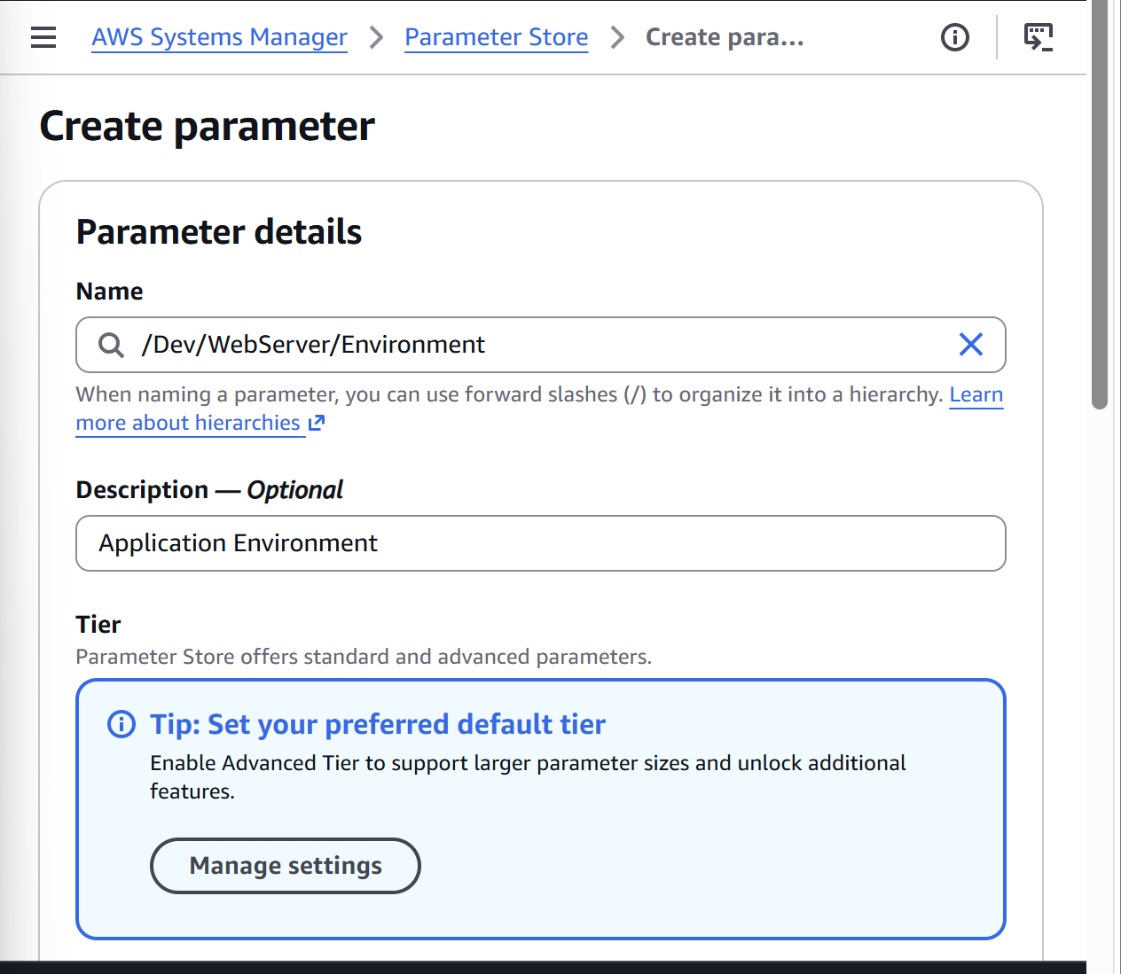
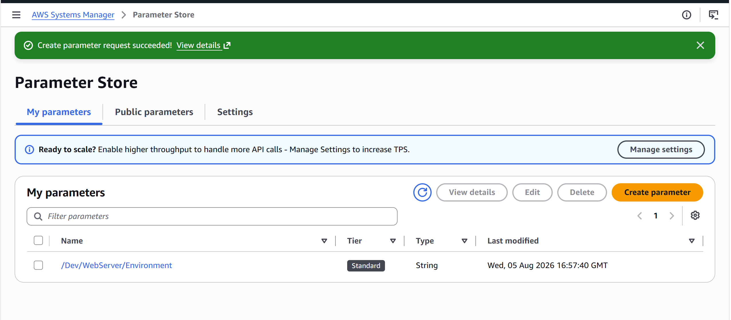

Step 4: Verify the Parameter
Open
Parameter Store
You should see:
Name | Type
/Dev/WebServer/Environment | String
Click the parameter.
You can see:
- Name
- ARN
- Version
- Value
- Last modified
- Tier
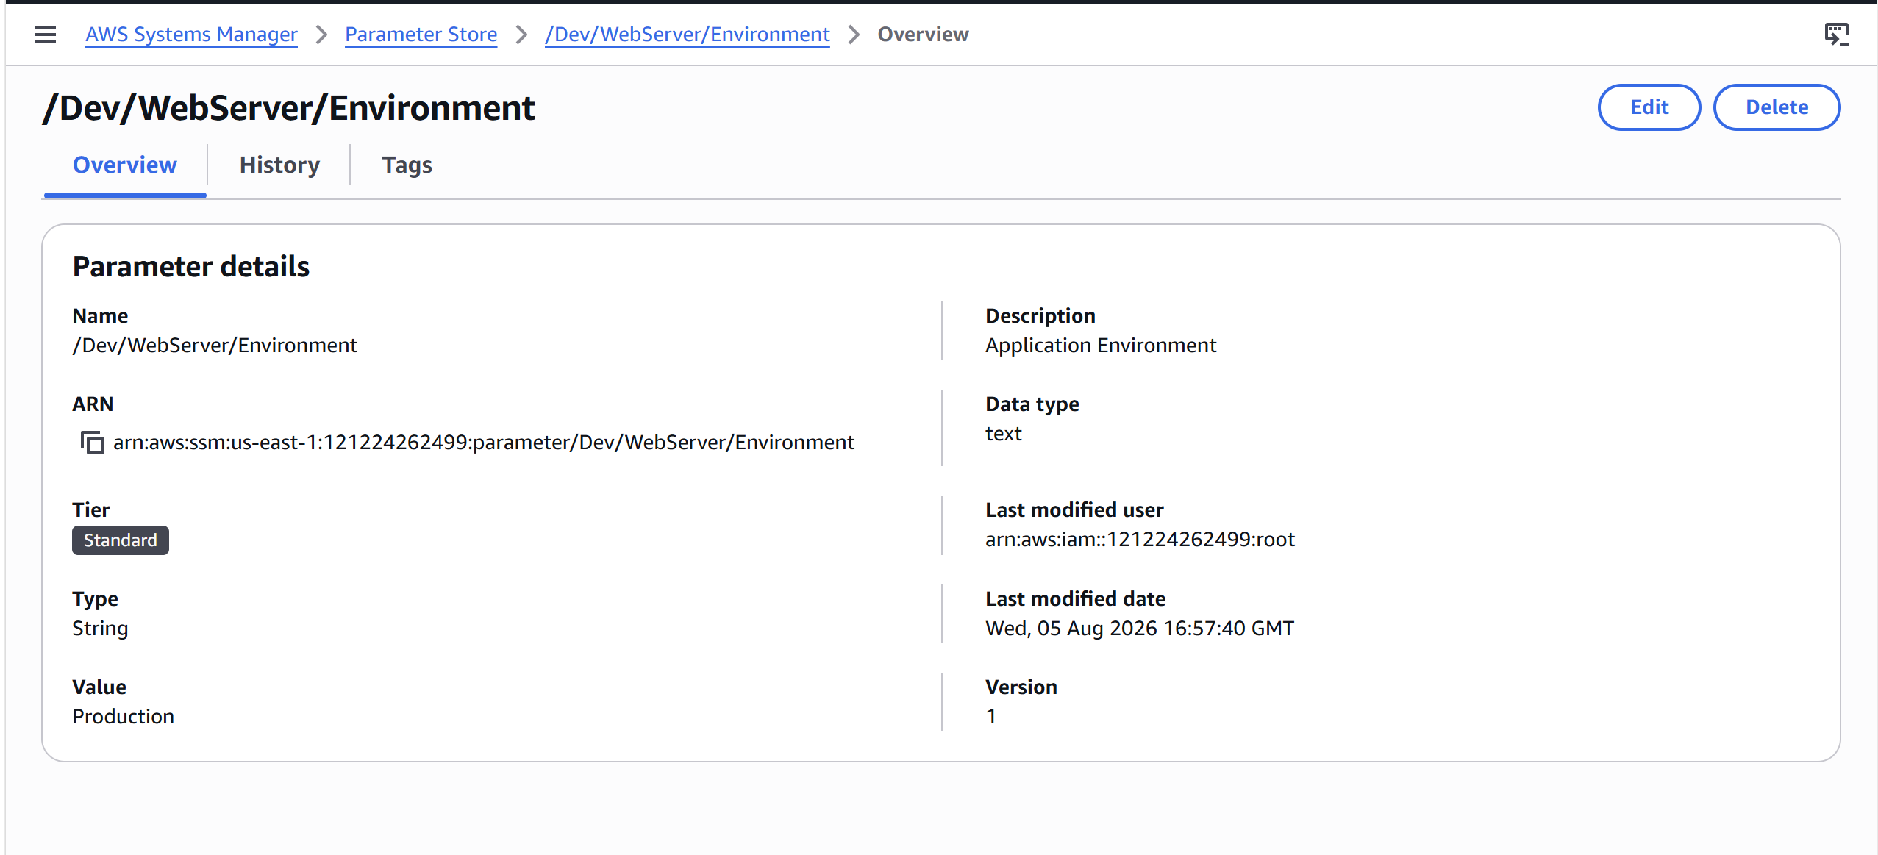

Step 5: Create a SecureString Parameter
Click
Create Parameter
Enter:
Name
/Dev/WebServer/DBPassword
Description
Database Password
Tier
Standard
Type
SecureString
KMS Key
Select
alias/aws/ssm
(or your customer-managed KMS key)
Value
MySecurePassword123!
Click
Create Parameter
The value is encrypted using AWS KMS.
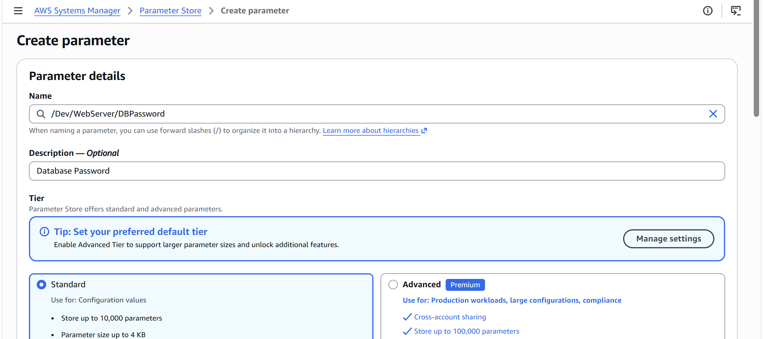
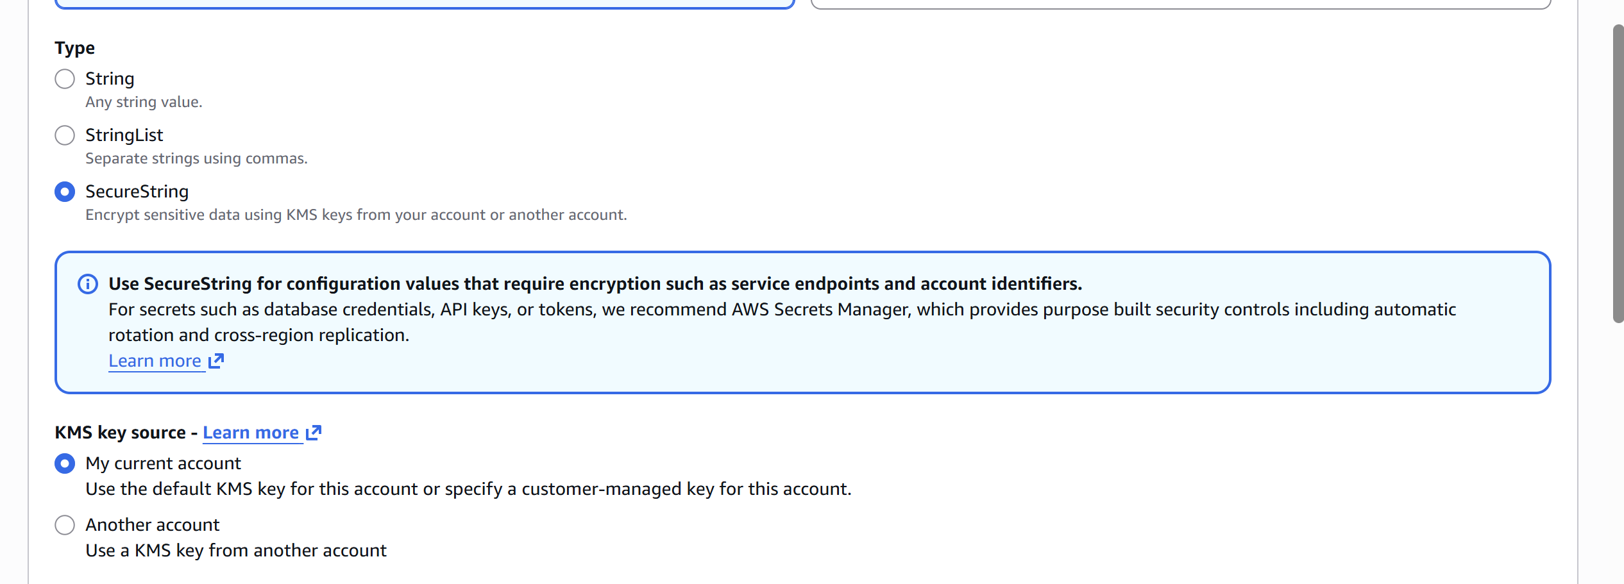

Step 6: View Secure Parameter
Click the parameter.
You will notice:
***************
The actual value is hidden.
Only authorized IAM users can decrypt it.
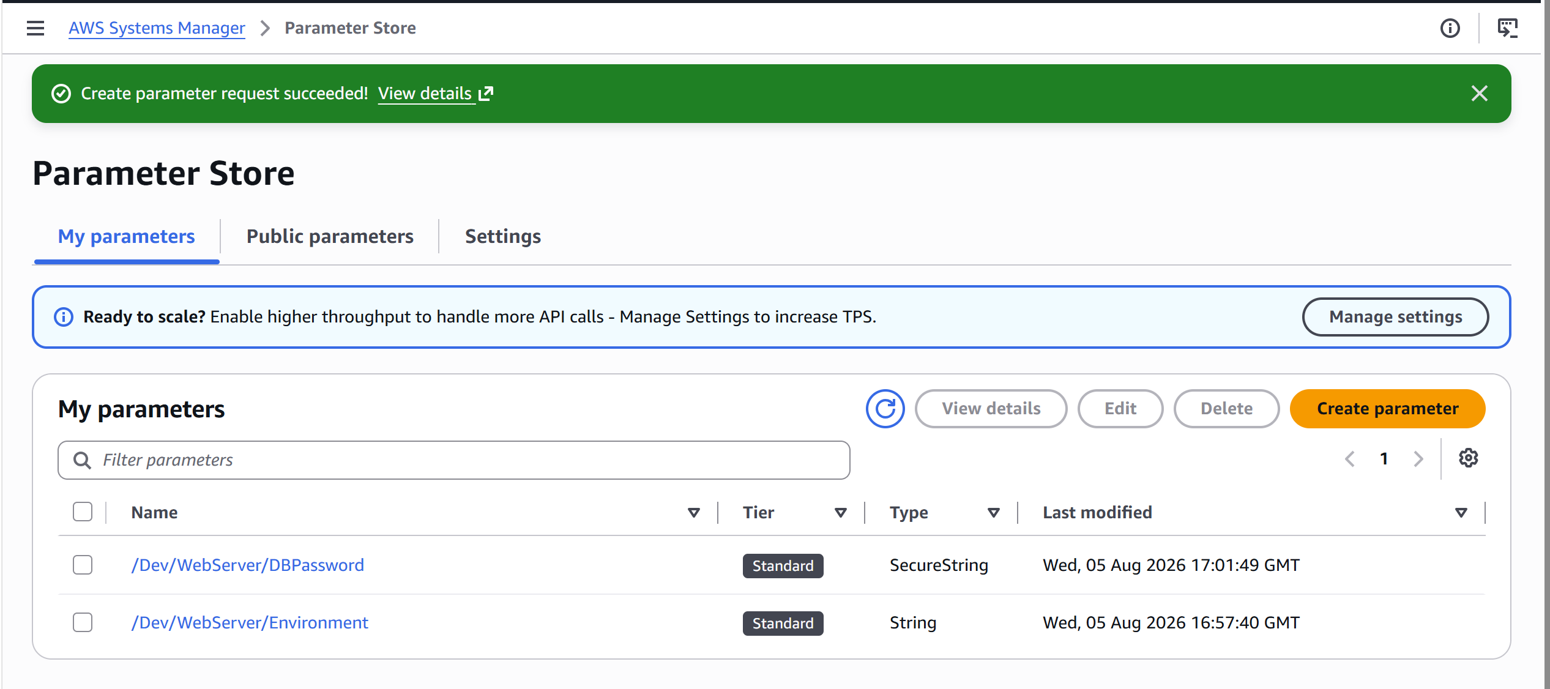

Step 7: Create a StringList Parameter
Click
Create Parameter
Name
/Dev/WebServer/Subnets
Type
StringList
Value
subnet-11111111,subnet-22222222,subnet-33333333
Click
Create Parameter
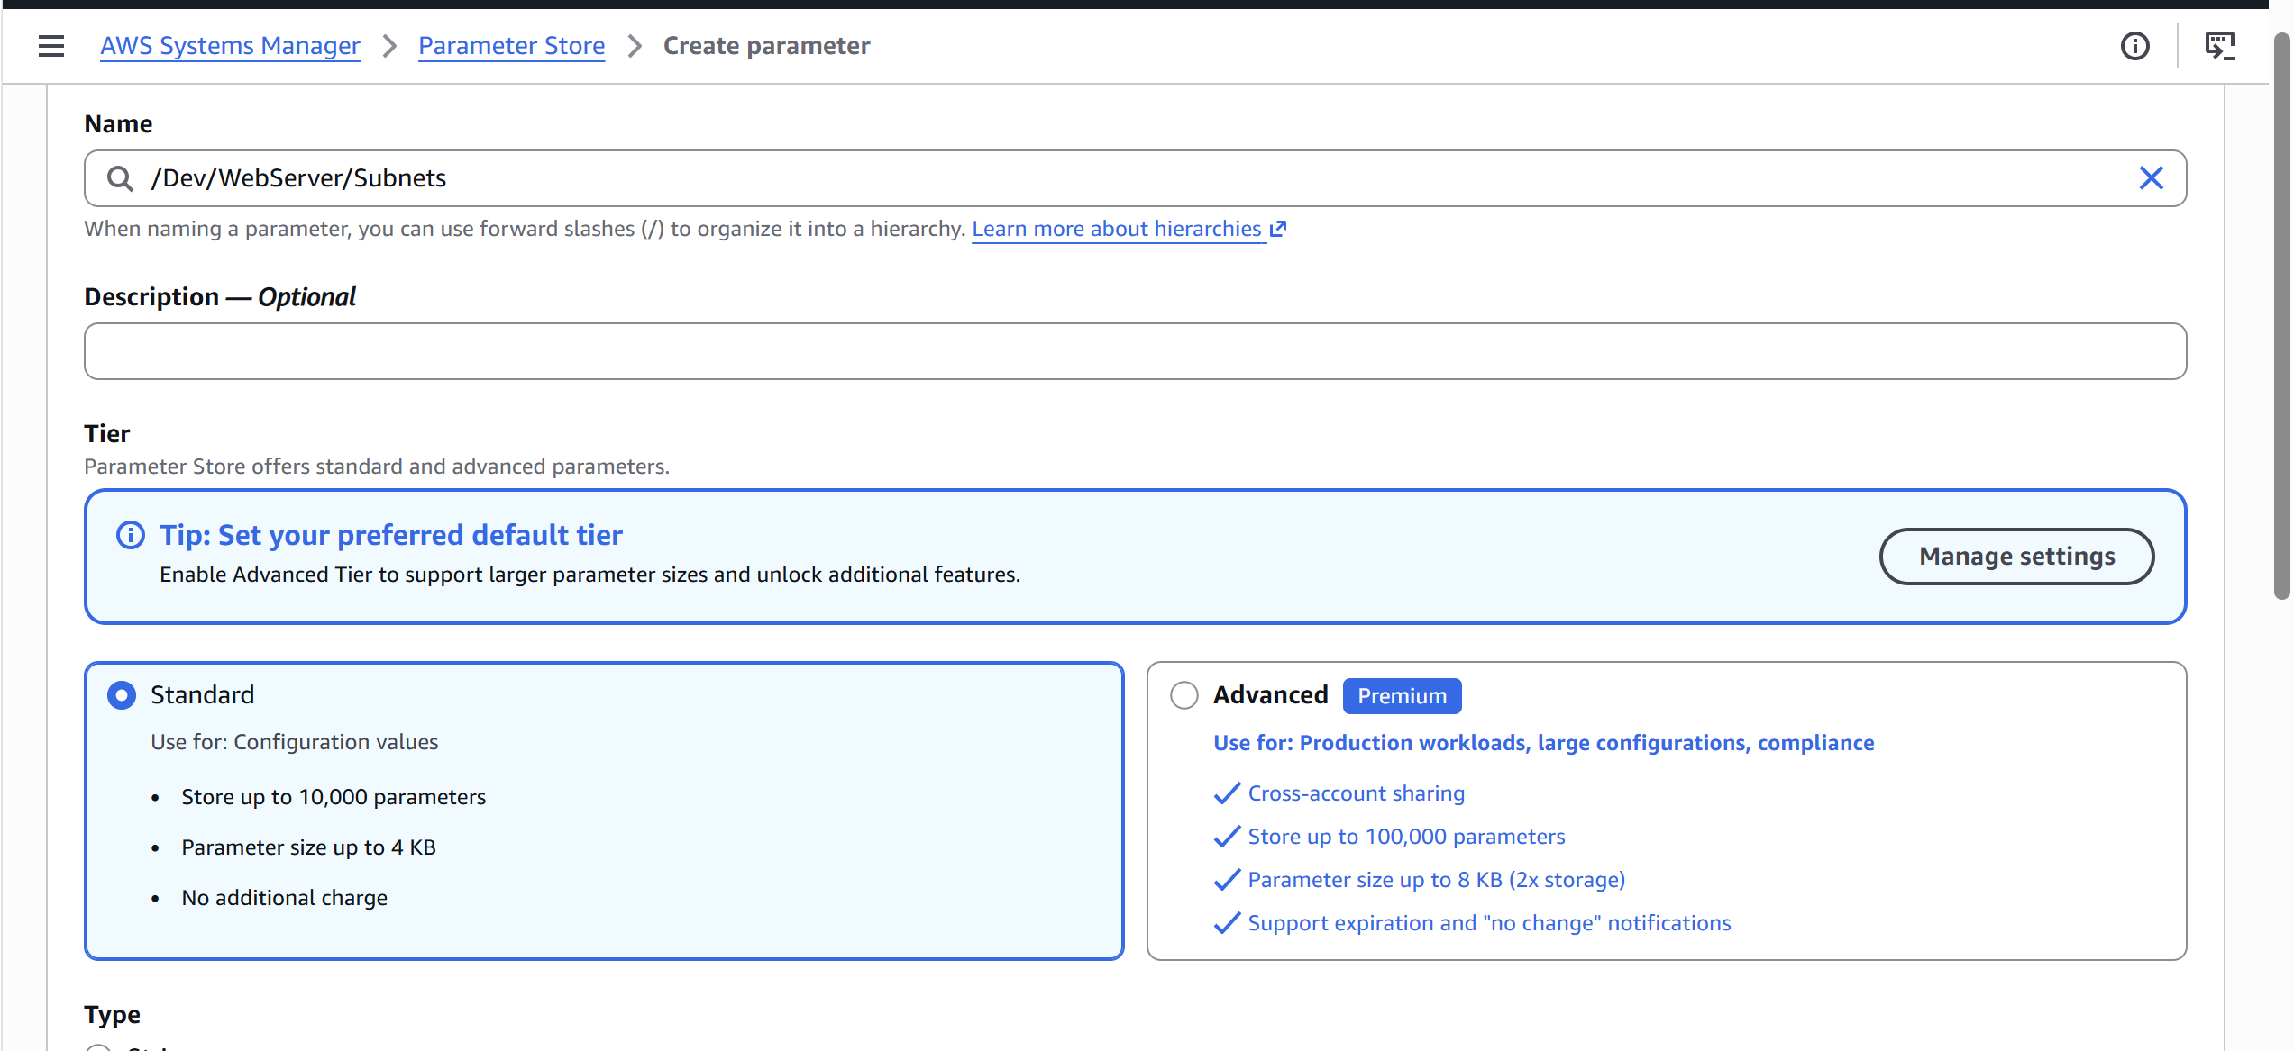
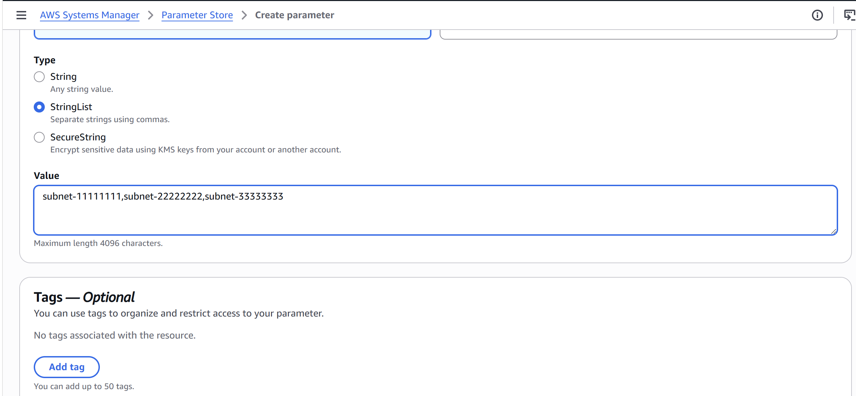
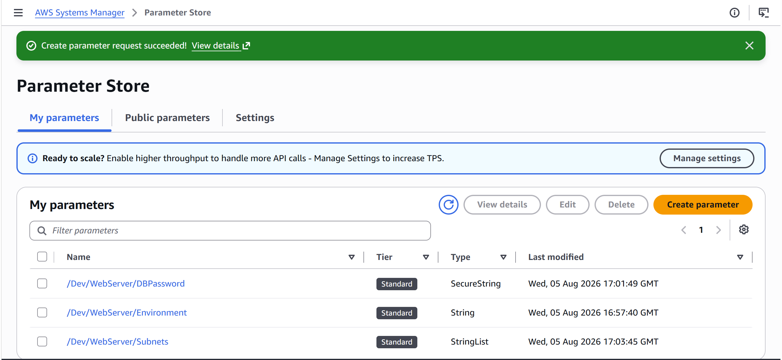

Step 8: Retrieve Parameters Using AWS CLI
Open your terminal (or connect to your EC2 instance).
Retrieve a String parameter
aws ssm get-parameter \
--name "/Dev/WebServer/Environment"
Expected output:
{
"Parameter": {
"Name": "/Dev/WebServer/Environment",
"Type": "String",
"Value": "Production"
}
}

Retrieve a SecureString parameter (decrypted)
aws ssm get-parameter \
--name "/Dev/WebServer/DBPassword" \
--with-decryption
Without --with-decryption, the encrypted value is returned.

Retrieve multiple parameters
aws ssm get-parameters \
--names "/Dev/WebServer/Environment" "/Dev/WebServer/DBPassword" \
--with-decryption

Retrieve parameters by path
aws ssm get-parameters-by-path \
--path "/Dev/WebServer"

Step 9: Update a Parameter
Select the parameter.
Click
Edit
Change
Production
to
Development
Click
Save
Version changes from:
Version 1
to
Version 2
Parameter Store automatically tracks versions.

Step 10: View Parameter History
Open the parameter.
Click
History
You will see:
Version 1

↓

Version 2

↓

Version 3
Each update creates a new version.

Step 11: Delete a Parameter
Select the parameter.
Click
Delete
Confirm
Delete
The parameter is permanently removed.

Step 12: Access Parameter from an EC2 Instance
- Launch an EC2 instance with an IAM role that includes AmazonSSMReadOnlyAccess (or equivalent permissions).
- Connect to the instance.
- Retrieve the parameter:
aws ssm get-parameter \
--name "/Dev/WebServer/Environment"
Output:
{
"Parameter": {
"Name": "/Dev/WebServer/Environment",
"Type": "String",
"Value": "Development"
}
}

Step 13: (Optional) Use Parameter Store in AWS Lambda
- Create a Lambda function.
- Attach IAM permissions such as ssm:GetParameter (and kms:Decrypt if using SecureString).
- Use the AWS SDK (for example, Boto3 in Python) to retrieve the parameter at runtime instead of storing secrets in environment variables.

Common AWS CLI Commands
Create a parameter:
aws ssm put-parameter \
--name "/Dev/WebServer/Environment" \
--value "Production" \
--type String
Overwrite an existing parameter:
aws ssm put-parameter \
--name "/Dev/WebServer/Environment" \
--value "Development" \
--type String \
--overwrite
Delete a parameter:
aws ssm delete-parameter \
--name "/Dev/WebServer/Environment"
List parameters:
aws ssm describe-parameters
